**Innovation of New FIA System and Its Application**

**for the Determination of Bismuth (III) in Procto-cinolone Ointment**

**Prof. Dr. Dakhil Nassir Taha* & Amal Saadoon Majeed\*\***

* Professor in Analytical Chemistry-chemistry department-College of Science/ Babylon University, Iraq [dakhilfia@yahoo.com](mailto:dakhilfia@yahoo.com).

** Assist. Lecturer in Analytical Chemistry-Basic medical sciences department-College of Nursing/ Kufa University, Iraq

[majeedamal@yahoo.com](mailto:majeedamal@yahoo.com).

**Abstract:**

New flow injection unit is designed for the determination of bismuth (III) via its reaction with thiourea to form yellow complex which gives maximum absorption at λmax=465 nm. This method includes home-made manufacturing of new flow injection valve from available, inexpensive, and harmless for the environment. The valve contains 6 sub-valves which arranged in two different levels. The best design of manifold was chosen as well as the study of optimum conditions. The calibration graph was linear over the range 0.01-50.00 μg.ml-1 (R2=0.9972) with detection limit (S/N=3) of 5 ng.ml-1 and the limit of quantification (S/N=10) was 0.5 μg.ml-1. Dispersion was 1.32, 1.13 for the two concentrations 5 and 10 μg.ml-1 respectively. Through the high repeatability and the dead volume of the unit, which was zero, the accuracy and efficiency of the innovated system are clarified for the determination of the studied ion. The effect of foreign ions was studied and the interference of ions was treated by using appropriate masking agent. This method was successfully applied for the determination of Bi(III) in pharmaceutical formulation.

**Keywords:** Flow Injection Analysis**,** Bi (III) determination, thiourea, ointment.

**1. Introduction:**

Bismuth is one of the less toxic heavy metals which presents in the earth's crust at trace concentration (only 0.00002%). The major uses of bismuth are in alloys, cosmetic products such as creams, hair dyes and tints, glass and ceramic industry, and other uses. But bismuth-containing drugs have been widely used, especially in topical dermatological creams and ointments. The toxic effects on environment and other systems must be considered (1-4).

According to the mentioned above, a simple, rapid, and inexpensive methods are necessary for the determination of trace amounts of bismuth (III) in medical, environmental, and other applications.

The most important field in analytical chemistry is pharmaceutical analysis which is related to the quality control of pharmaceuticals (5,6). FIA techniques demonstrate numerous advantages in pharmaceutical analysis according to the literatures (7-9).

The aim of the present work is design an innovative valve with six sub-valve distributed in two different levels. This valve is very important part of a new flow injection system. The FIA system is used for the determination of trace amount of Bi (III). This method is based on the reaction of Bi (III) with thiourea to form yellow complex which absorbed at 465 nm. The method combines all the advantages of FIA with rapidity, low cost, wide range of calibration curve, and satisfactory limit of detection. The proposed method was successfully applied for the determination of bismuth in pharmaceutical product.

**2. Experimental**

2.1. Instrumentation

The schematic diagram of FIA system is illustrated in Fig.1. It consisted –from right to left- of peristaltic pump (ismatic, Germany), the homemade 10-port valve (5 ports for inlet and the rest for outlet), UV-Visible spectrophotometer (Apple), flow cell (450 μL, Helmma), kompensograph (C 1032 Siemens, Germany), and Teflon tubing throughout of i.d. 1 mm is used.

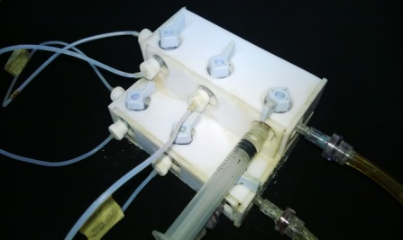

**Fig.1: The schematic diagram of new FIA system with photo of the innovative valve.**

2.2. Reagents and solutions

The chemicals were of analytical-reagent grade and used without further purification. Distilled water was used to prepare all solution.

A stock standard solution of 1000 μg.mL-1 Bi (III) was prepared by dissolving 0.2324 g of Bi(NO3)3.5H2O in 10 mL of 3 mol.L-1 HNO3 to avoid the Bi (III) hydrolysis, then diluted to 100 mL volumetric flask with distilled water (10,11). Thiourea of 7% was prepared by dissolving 7g in 100 mL distilled water. Working solutions were prepared daily by dilution of stock solutions with distilled water.

**3. Results and discussion**

3.1. UV-Visible spectrum

In this study, the test solution was prepared by adding 7% of thiourea to 200 μg.mL-1 of bismuth (III) to give a yellow-coloured complex. The results showed that the complex could absorbed at λmax= 465 nm according to Fig.2, and this is agreed with the literatures (11,12).

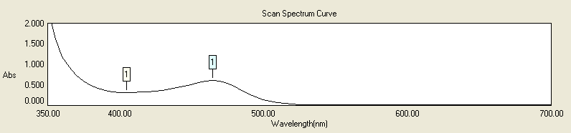

**Fig.2: The UV-Visible spectrum of bismuth –thiourea complex**

3.2. Study of optimum conditions

3.2.1. Chemical conditions

After choosing the best design of FIA manifold (Fig.1), under the conditions of 10 μg.mL-1 Bi (III), 6% thiourea, 0.1 mol.L-1 HNO3, the flow rate was 15.10 mL. min-1, the length of reaction coil was 60 cm, and 157.00 μL was the volume of Bi (III) and thiourea. The effect of thiourea concentration was studied and the range of thiourea concentrations was from 2% to 8%. The preferred response was at the concentration 7% of thiourea according to the results in table:1 and Fig. 3.

**Table (1): The relationship between thiourea concentration and response (mV)**

|  |  |  |  |  |  |  |
| --- | --- | --- | --- | --- | --- | --- |
| **Conc. of thiourea %** | **Peak Height (mV)** | | | **Mean $\overline{Y}$** | **S.D** | **R.S.D%** |
| 2 | 18 | 18 | 18 | 18 | 0.00 | 0.00 |
| 3 | 30 | 32 | 30 | 30.67 | 1.16 | 3.78 |
| 4 | 36 | 38 | 38 | 37.34 | 1.16 | 3.11 |
| 5 | 48 | 46 | 48 | 47.34 | 1.16 | 2.45 |
| 6 | 58 | 56 | 56 | 56.67 | 1.16 | 2.05 |
| ***7*** | ***65*** | ***64*** | ***65*** | ***64.67*** | ***0.58*** | ***0.89*** |
| 8 | 65 | 65 | 65 | 65 | 0.00 | 0.00 |

**Fig.3: Effect of thiourea concentration on the response**

The effect of HNO3 concentration was also studied and the range of concentrations was (0.01-0.5) mol.L-1. The HNO3 concentration which gave the best peak height was 0.1 mol.L-1 , as shown in table:2 and Fig.4.

**Table (2): The relationship between nitric acid concentration and response (mV)**

|  |  |  |  |  |  |  |
| --- | --- | --- | --- | --- | --- | --- |
| **Conc. of HNO3 mol.L-1** | **Peak Height (mV)** | | | **Mean $\overline{Y}$** | **S.D** | **R.S.D%** |
| 0.01 | 46 | 46 | 48 | 46.67 | 1.16 | 2.49 |
| 0.05 | 58 | 58 | 56 | 57.34 | 1.16 | 2.02 |
| ***0.1*** | ***66*** | ***66*** | ***65*** | ***65.67*** | ***0.58*** | ***0.88*** |
| 0.3 | 54 | 54 | 54 | 54 | 0.00 | 0.00 |
| 0.5 | 44 | 44 | 44 | 44 | 0.00 | 0.00 |

**Fig.4: Effect of HNO3 concentration on the response**

3.2.2. Physical conditions

Effect of flow rate

The study of flow rate and its effect on the peak height was conducted over the range (1.9-16.75) mL.min-1. Although, the highest peaks were at low flow rates but the form of response was distorted, partitioned, and broader. This is due to irregular diffusion which causes to form two zones (at the same peak) the first with high mixing and the other with low mixing (13). The preferred flow rate was at 8.55 mL.min-1according to the results in table:3, and Fig.5. The flow rates higher than 8.55 mL.min-1 led to low sensitivity because at high flow rates the fraction of analyte molecules is removed by carrier solution (0.1 mol.L-1 HNO3). That would not give the chance for the analyte fraction enough time to stay in flow cell and passes before the detector (14,15).

**Table (3): The effect of flow rate on the form and sensitivity of response**

|  |  |  |  |  |  |  |  |  |  |
| --- | --- | --- | --- | --- | --- | --- | --- | --- | --- |
| **Speed of pump mL.min-1** | **Flow rate mL.min-1** | **Peak height (mV)** | | | **Mean $\overline{Y}$** | **S.D** | **R.S.D%** | **Base peak width (s)** | **The response form** |
| 10 | 1.90 | 112 | 110 | 110 | 110.67 | 1.16 | 1.05 | 1800 | Distorted, partitioned, and very broad |
| 20 | 3.55 | 81 | 80 | 80 | 80.34 | 0.58 | 0.72 | 900 | Distorted, partitioned, and broad |
| 30 | 5.05 | 79 | 79 | 78 | 78.67 | 0.58 | 0.74 | 600 | Slightly distorted and broad |
| 40 | 6.80 | 74 | 73 | 72 | 73 | 1.00 | 1.37 | 300 | Slightly distorted and broad |
| ***50*** | ***8.55*** | ***69*** | ***69*** | ***69*** | ***69*** | ***0.00*** | ***0.00*** | ***120*** | ***Good peak (sharp and narrow)*** |
| 60 | 10.10 | 67 | 68 | 67 | 67.34 | 0.58 | 0.86 | 60 | Good peak (sharp and narrow) |
| 70 | 12.10 | 67 | 67 | 68 | 67.34 | 0.58 | 0.86 | 60 | Good peak (sharp and narrow) |
| 80 | 13.90 | 67 | 67 | 65 | 66.34 | 1.16 | 1.75 | 60 | Good peak (sharp and narrow) |
| 90 | 15.10 | 65 | 65 | 65 | 65 | 0.00 | 0.00 | 30 | Good peak (sharp and very narrow) |
| 100 | 16.75 | 65 | 63 | 65 | 64.34 | 1.16 | 1.80 | 30 | Good peak (sharp and very narrow) |

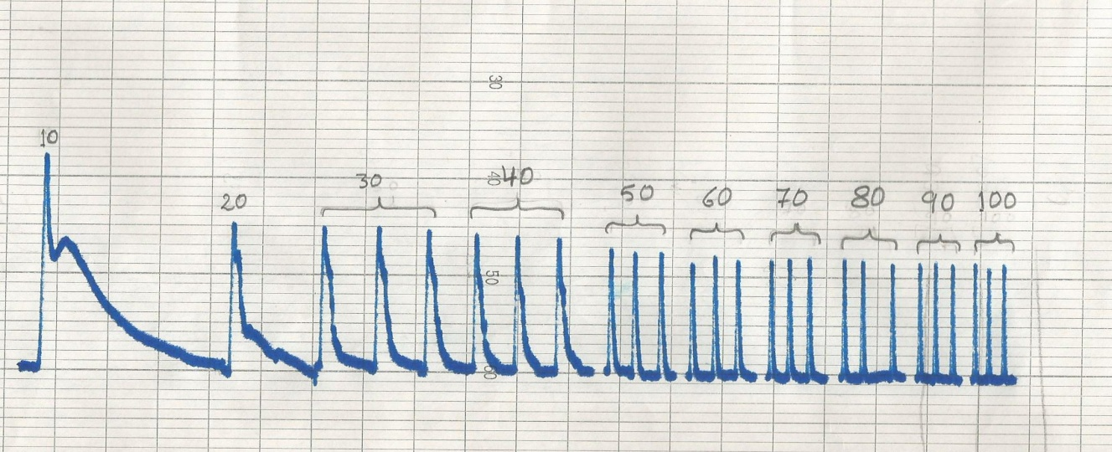

**1.90 3.55 5.05 6.80 8.55 10.10 12.10 13.90 15.10 16.75**

**Fig. 5: Effect of flow rate (mL.min-1) on the form and height of response (mV)**

Effect of reaction coil length

This study was achieved by using different lengths of reaction coils (35-120) cm. It was noticed that there is an increase in the sensitivity of response with decreasing of reaction coil length. For that reason, the conclusion of removing the reaction coil from the manifold could increase the peak height and that was proved experimentally. According to the results in table:4 and Fig.5, the reaction between Bi(III) and thiourea is rapid, therefore there is no need to further mixing.

**Table (4): The relationship between reaction coil length (cm) and the response (mV)**

|  |  |  |  |  |  |  |
| --- | --- | --- | --- | --- | --- | --- |
| **Reaction coil length (cm)** | **Peak height (mV)** | | | **Mean $$\overline{Y}$$** | **S.D** | **R.S.D%** |
| ***Without*** | ***98*** | ***100*** | ***98*** | ***98.67*** | ***1.16*** | ***1.18*** |
| 35 | 94 | 92 | 92 | 92.67 | 1.16 | 1.25 |
| 60 | 68 | 70 | 70 | 69.34 | 1.16 | 1.67 |
| 75 | 50 | 50 | 50 | 50 | 0.00 | 0.00 |
| 120 | 30 | 30 | 30 | 30 | 0.00 | 0.00 |

**Fig.5: The effect of reaction coil length on the response sensitivity**

Effect of thiourea volume

The effect of thiourea volume on the form and sensitivity of response was studied over the range (86.35 - 274.75) μL. It was noticed that the highest peak is obtained at 196.25 μL of thiourea, as shown in table:5 and Fig.6.

**Table (5): The relationship between thiourea volume (μL) and the response (mV)**

|  |  |  |  |  |  |  |
| --- | --- | --- | --- | --- | --- | --- |
| **The volume of thiourea (μL)** | **Peak height (mV)** | | | **Mean $\overline{Y}$** | **S.D** | **R.S.D%** |
| 86.35 | 72 | 70 | 70 | 70.67 | 1.16 | 1.64 |
| 117.75 | 90 | 90 | 88 | 89.34 | 1.16 | 1.29 |
| 157.00 | 100 | 100 | 100 | 100 | 0.00 | 0.00 |
| ***196.25*** | ***120*** | ***122*** | ***122*** | ***121.34*** | ***1.16*** | ***0.96*** |
| 235.50 | 92 | 90 | 92 | 91.34 | 1.16 | 1.27 |
| 274.75 | 90 | 88 | 88 | 88.67 | 1.16 | 1.31 |

**Fig.6: Effect of Thiourea volume on the response**

Effect of sample volume

The effect of sample volume was also studied using the optimum parameters. Variable sample volumes (86.35 – 235.50) μL were injected through the home-made injection valve. From the results in table:6 and Fig.7, it was noticed that the optimum sample volume was 157.00 μL.

**Table (6): The relationship between sample volume (μL) and the response (mV)**

|  |  |  |  |  |  |  |
| --- | --- | --- | --- | --- | --- | --- |
| **The volume of sample (μL)** | **Peak height (mV)** | | | **Mean $\overline{Y}$** | **S.D** | **R.S.D%** |
| 86.35 | 88 | 87 | 89 | 88 | 1.00 | 1.14 |
| 117.75 | 102 | 102 | 102 | 102 | 0.00 | 0.00 |
| ***157.00*** | ***122*** | ***120*** | ***120*** | ***120.67*** | ***1.16*** | ***0.96*** |
| 196.25 | 100 | 100 | 100 | 100 | 0.00 | 0.00 |
| 235.50 | 90 | 92 | 92 | 91.34 | 1.16 | 1.27 |

**Fig.7: The effect of sample volume (μL) on the response (mV)**

3.3. The construction of calibration graph

Under the optimum parameters conducted in previous sections, a series of Bi(III) concentrations were prepared to study the calibration graph. The calibration graph (Fig.8) showed linearity over the range (0.01-50) μg.mL-1 (R2=0.9972). The limit of detection ((S/N=3) was 5 ng.ml-1 and the limit of quantification (S/N=10) was 0.5 μg.ml-1.



**Fig.8: The calibration graph for variable Bi (III) concentrations**

3.4. Statistical analysis (16,17)

All measurements were replicated three times (n=3) and the results were expressed as (mean ± $t_{0.025 }\frac{S.D}{\sqrt{n}}$). The data were analysed statistically by the analysis of variance (ANOVA) and student ʻtʼ test according to the tables (7) and (8).

**Table (7): Summary of linear regression equation results of the form Y=bX+a for the determination of Bi (III)**

|  |  |  |  |  |  |
| --- | --- | --- | --- | --- | --- |
| **Linear range μg.mL-1** | **No. of measurements (n)** | **Straight line equation $\hat{Y}=\left(a±s_{a}t\right)+(b±s_{b })[Bi\left(III\right)]$** | **Correlation coefficient (r)** | **Calculated t-value = $\frac{/r/\sqrt{n-2}}{\sqrt{1-r^{2}}}$** | **Tabulated t-value at 95% confidence interval** |
| 0.01-50 | 14 | $\hat{Y}$ =17.70±4.07+10.90±65.66 [Bi(III)] | 0.9986 | 65.39 | 2.18 |

$\hat{Y}$**= Estimated response (mV)**

It was noticed from the results in table (7) that tcal is greater than ttab (65.39>>2.18), therefore the null hypothesis (H0), when ttab is greater than tcal and r = 0, is rejected because r = 0.9986 and the alternative hypothesis (H1) is accepted which shows that the relationship between peak height (mV) and Bi(III) concentration (μg.mL-1) is linear.

**Table (8): The results of ANOVA test for straight line equation Y= bX+a**

|  |  |  |  |  |  |
| --- | --- | --- | --- | --- | --- |
| **Source of variance** | **Sum of squares (SSq)** | **Degree of freedom (Df)** | **Mean squares (MSq)** | **F-statistic $F=\frac{S_{1}^{2}}{S_{0}^{2}}$** | **F-tabulated** |
| Due to regression |  | ν1=1 |  | 4310.62 | 4.75 |
| Due to error (about regression) |  | ν2 (n-2)=12 |  |
| Total | 496206.93 | νTotal (n-1)=13 |

The critical value Ftab is less than the calculated value of F (Fstat = 4310.62). Therefore, there is significant difference at 95% confidence interval between the variance due to regression and the variance due to error (about regression). Thus, the results approach to ideal state (linearity), as shows in table (8).

3.5. Repeatability

Two concentrations 5 and 10 μg.mL-1 of Bi (III) were used to study the repeatability of measurements and the efficiency of new FIA system. Twelve successive injections were measured under the optimum conditions which had conducted in previous sections. The obtained results are tabulated in table (9), while Fig.9 shows the form of responses for the two concentrations.

|  |  |  |  |  |  |  |  |  |  |  |
| --- | --- | --- | --- | --- | --- | --- | --- | --- | --- | --- |
| $\overline{Y}∓t_{0.025 }\frac{S.D}{\sqrt{n}}$ | **RSD%** | **S.D** | **Mean $\overline{Y}$** | **Peak Height (mV)**  **n = 12** | | | | | | **Conc. of Bi(III) ppm** |
| 56.84 $∓$ 0.68 | 1.81 | 1.03 | 56.84 | 58 | 56 | 56 | 58 | 56 | 56 | 5 |
| 58 | 56 | 56 | 58 | 56 | 58 |
| 119.34 $∓$ 0.66 | 0.83 | 0.99 | 119.34 | 120 | 120 | 120 | 120 | 120 | 118 | 10 |
| 120 | 118 | 120 | 118 | 118 | 120 |

**Table (9): The repeatability of responses**





**5 μg.mL-1 of Bi(III)**

**10 μg.mL-1 of Bi(III)**

**Fig.9: The repeatability of responses for the two concentrations**

3.6. Dispersion

The coefficient of dispersion (D) is the most popular experimental parameter able to measure the degree of dilution of the sample from injection point until its passage before the detector. The dispersion coefficient (D) is easily calculable by using the following equation (18-20).

**D = H0 / Hmax**

Where:

**H0**: peak height without dilution outside the FIA system

**Hmax** : peak height with dilution inside the FIA system

Dispersion was 1.32, 1.13 for the two concentrations 5 and 10 μg.ml-1 respectively. The values of 1.32 and 1.13 represent limit dispersion in the manifold, as illustrated in Fig.10.

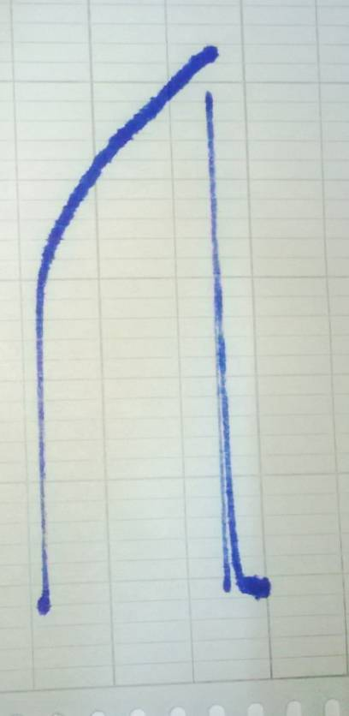****

**D=7.0/6.2=1.13**

**A**

**D=4.5/3.4=1.32**

**B**

**Fig.10: The dispersion for the two concentrations, A, 10 μg.ml-1 and B, 5 μg.ml-1**

3.7. The time of injection and appearance of response

The injection of all components of reaction in the home-made valve demands 20 seconds. The required time for response to start from baseline ascending to the peak maximum is 7 seconds, thus, the sampling rate is 514.29 sample/hr. But, the required time for response to start from baseline ascending to the peak maximum descending again to baseline is 60 seconds. It was also noticed that peak base width is 60 seconds and in this case the sampling rate becomes 60 sample/hr.

3.8. Interferences

The effect of foreign ions on the determination of Bi(III) was investigated using the optimum parameters. The foreign ions with different concentrations (2.5, 5, 10, and 50) μg.ml-1 were added individually to the sample solution containing 5 μg.ml-1 of Bi(III). The interfering ions were Fe2+, Fe3+, Ni2+, Co2+, Cu2+, Cl-, Br-, and I-. The interference of these ions was removed by adding appropriate masking agents.

3.9. Determination of bismuth (III) in pharmaceutical product

The proposed FIA method was successfully applied for the analysis of commercial Bi(III)-containing pharmaceutical product used for the treatment of Hemorrhoids, Anal pruritus, and proctitis. Each 1g of procto-cinolone ointment contains 50 mg of bismuth subgallate. 0.01g of the ointment was weighed and dissolved in 5 mL of HNO3 (65%, w/w) then evaporated near to dryness on a hot plate. The heating and evaporation were repeated again after adding 2 mL of HClO4 to the sample (21). The cooled residue was dissolved and completed up to 100 mL with 0.1 mol.L-1 of HNO3 to prepare solution containing 5 μg.ml-1 of Bi(III).

**Table (10): Bismuth (III) content found in the analysed ointment**

|  |  |  |  |  |  |
| --- | --- | --- | --- | --- | --- |
| **Taken concentration μg.ml-1** | **Found concentration μg.ml-1** | **S.D** | **R.S.D%** | **Er%** | **Recovery%** |
| 0.50 | 0.45 | 0.06 | 5.77 | 6 | 94 |
| 1.00 | 0.88 | 0.06 | 4.72 | 3 | 97 |
| 5.00 | 4.66 | 0.06 | 1.59 | 0.6 | 99.4 |

The results obtained show good agreement with the labeled information given by the manufacturer. Also, there was a good agreement between the taken concentration and the recovered amounts of Bi (III), as shown above in table (10).

**4. Conclusion**

The new innovated system with single-channel manifold demonstrated to be efficient for the determination trace amounts of Bi (III). The method has wide linear range from 0.01 μg.ml-1 to 50 μg.ml-1 and low detection limit. The method fulfills all the main demands for pharmaceutical analysis such as, low cost, simplicity and rapidity. The results were very satisfactory indicating the validity and accuracy of the proposed FIA method for the determination of Bi (III) in the pharmaceutical formulation.

**References**

G. E. Housecroft & A. G. Sharpe, "Inorganic Chemistry", 2nd Edition, Pearson Education Limited, p:389, 2005.

N. N. Greenwood & A. Earnshsw, "Chemistry of the Elements", 2nd Edition, Butterworth-Heinemann, p:547, 1997.

S. S. Sandhu & J. S. Sandhu, "Recent Developments on Bismuth (III) Carbon-Carbon Bond Formation Chemistry", Rasāyan J. Chem., 4(1), pp:73,74, 2011.

F. Thomas, B. Bialek & R. Hensel, "Medical Use of Bismuth: the two sides of the coin", J. Clinic Toxicol, S:3, pp: 1-5, 2011.

S. Surekha, S. Nama, L. M. Pola, & C. B. Rao, "Recent Applications of Flow Injection Spectrophotometry", Inter. J. of Pharm. Research & Analysis, 3(2), p:77, 2013.

J. M. Calatayud, "Flow Injection Analysis of Pharmaceuticals: automation in the laboratory", Spain, Taylor & Francis, 1996.

A. Alonso, M. J. Almendral, M. D. Báez, M. J. Porras, F. López Lavín, & C. García de María, "Determination of bismuth in pharmaceutical products using liquid-liquid extraction in a flow injection system", Analytica Chimica Acta, 408, p:129, 2000.

P. D. Tzanavaras, D. G. Themelis, & A. Economou, "Sequential injection method for the direct spectrophotometric determination of bismuth in pharmaceutical products", Analytica Chimica Acta, 505, p:167, 2004.

P. C. A. Jerónimo, A. N. Araújo, M. Conceição, B. S. M. Montenegro, D. Satinský, & P. Solich, "Coloimetric bismuth determination in pharmaceuticals using a xylenol orange sol-gel sensor coupled to a multicommutated flow system", Analytica Chimica Acta, 504, p:235, 2004.

M. A. Taher, M. Rahimi, & H. Fazelirad, "A sensitive fluorescence quenching method for determination of bismuth with tiron", journal of luminescence, 145, p:977, 2014.

Z. Marczenko, "Spectrophotometric Determination of Elements", 1st Edition, English Published, pp:151, 155, 156, 1976.

V. N. Alexeyev, "Qualitative Analysis", translated by E. B. Uvarov, Mir Publishers, Moscow, p:365, 1971.

A. S. Farhood Al-Kafaji & D. N. Taha Al-Zerkany, "Design of Flow Injection Analysis Unit Merging Zone Technique for the Determination of Adsorbed Phenol on Activated Carbon Surface Prepared from some Local Plants Husks", M.Sc. Thesis, Babylon University, 2011.

R. Toniolo, A. Pizzariello, S. Susmel, N. Dossi, and G. Bontempelli, "A sensor based on electrodes supported on ion-exchange membranes for the flow-injection monitoring of sulphur dioxide in wines and grape juices", Talanta, 80, p:1814, 2010.

F. F. Ali Al-Zaydany & D. N. Taha Al-Zerkany, "Determination of Cerium (IV) by Flow Injection Analysis Merging Zone Technique Via (Ce4+, I- and H3O+) System", Ph.D. Thesis, Babylon University, 2013.

J. N. Miller & J. C. Miller, "Statistics and Chemometrics for Analytical Chemistry", 6th Edition, Pearson Education Limited, 2010.

D. B. Hibbert & J. J. Gooding, "Data Analysis for Chemistry: An Introductory Guide for Students and Laboratory Scientists", Oxford University Press, Inc., 2006.

M. Trojanowicz, "Advances in Flow Analysis", WILEY-VCH, p:16, 2008.

D. N. Taha, "A novel method for determination of hydrazine via semi-automated on-line merging zone technique", National J. of chemistry, 14,269-278, 2004.

D. N. Taha, "New mode for spectrophotometric determination of nanogram levels of total Iron (II) and Iron (III)by flow –injection analysis merging reaction zone for the release of iodine using valve double loops for (Fe(III),I-,H3O+) system", National J. of chemistry, 13,43-46, 2004.

M. M. Hassanien & A. Z. Ali, "Determination of bismuth traces by HG-ICP-OES after separation by cloud point extraction using thiourea and iodide mixture", Arab J Sci Eng, 37, p:1274, 2012.